REPORT ON BIZORA – A MANAGEMENT FEST
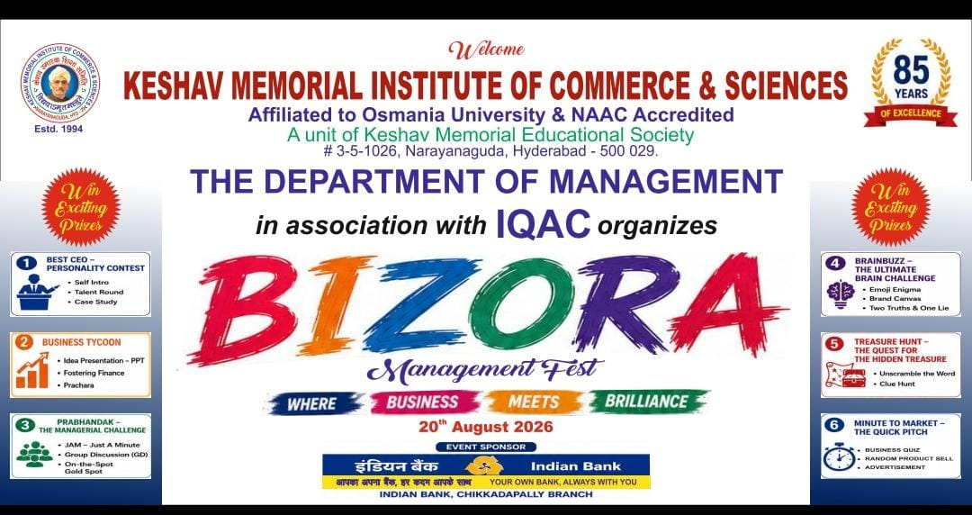
A Celebration of Business, Creativity & Management Skills
Organized by: Department of BBA
Keshav Memorial Institute of Commerce & Sciences (KMICS), Hyderabad
Date: 20 August 2026
Venue: KMICS Campus
1. Introduction
The Department of BBA, Keshav Memorial Institute of Commerce & Sciences (KMICS), successfully organized “BIZORA – A Management Fest” on 20 August 2026. The event was designed to provide students with a vibrant platform to demonstrate their business acumen, managerial skills, creativity, communication abilities, leadership qualities, analytical thinking and entrepreneurial spirit.
The Management Fest witnessed enthusiastic participation from students representing 21 colleges. A total of 268 responses were received through the online registration form, reflecting the strong interest and response from the student community.
2. Objectives of the Event
The major objectives of BIZORA were:
- To provide students with practical exposure to management concepts.
- To develop leadership, decision-making and problem-solving skills.
- To encourage creativity, innovation and entrepreneurial thinking.
- To strengthen communication, teamwork and competitive spirit.
- To provide an inter-collegiate platform for students to showcase their managerial talents.
- To bridge the gap between classroom learning and practical business situations.
3. Inaugural Ceremony
The event commenced with the Inauguration Ceremony at 10:00 AM.
Chief Guest:
Sri K. Srinivas, Deputy General Manager / Zonal Manager, Indian Bank
Guest of Honour:
Dr. J. Nageswar Rao, Director, KMES
The dignitaries addressed the participants and emphasized the importance of practical learning, leadership, innovation and professional skills in developing successful future managers and entrepreneurs.
The inaugural ceremony set an energetic and inspiring tone for the various competitions conducted throughout the day. Principal Mrs.shravanthi Appreciated the Department & address welcome note.
4. Events Conducted
BIZORA comprised six engaging management and skill-based events:
1. Best CEO
An event designed to test leadership qualities, decision-making ability, business vision, communication skills and managerial competence.
2. Business Tycoon
A business-oriented competition that challenged participants to demonstrate entrepreneurial thinking, strategic planning, financial understanding and business decision-making.
3. Prabandhak
A management-focused event designed to assess participants' administrative abilities, leadership skills, problem-solving capabilities and managerial judgement.
4. Brain Buzz
A challenging intellectual competition testing general awareness, business knowledge, logical reasoning, analytical ability and quick thinking.
5. Minute to Market
A creative business-pitching event where participants were required to develop and present innovative marketing ideas within a limited time.
6. Treasure Hunt
A team-based activity designed to develop logical thinking, observation, coordination, communication and problem-solving skills in an enjoyable and competitive environment.
5. Registration and Participation Analysis
The online registration form received 268 responses.
Course-wise Participation
Course | Responses | Percentage
BBA | 181 | 67.5%
B.Com | 54 | 20.1%
B.Sc | 24 | 9.0%
BBA – Business Analytics | 4 | 1.5%
B.A. | 4 | 1.5%
B.Tech | 1 | 0.4%
Total | 268 | 100%
The largest participation came from BBA students (67.5%), followed by B.Com students (20.1%) and B.Sc students (9%).
The participation was particularly strong among 1st and 2nd year students, together accounting for more than 96% of the registrations.
6. Event-wise Participation
The registration data recorded 227 responses with event selections. Since participants were permitted to register for more than one event, the event-wise participation exceeds the number of individual respondents.
Brain Buzz recorded the highest participation with 117 selections, followed by Treasure Hunt with 73 selections. The strong response to these events demonstrated students' enthusiasm for knowledge-based, analytical and team-oriented activities.
Overall, the six events generated 342 event selections, indicating that several participants registered for multiple competitions.
7. Valedictory Ceremony
The Valedictory Ceremony was held at 4:00 PM, marking the successful conclusion of BIZORA.
Chief Guest:
Dr. Anil Kumar Batchesu,
Aswini Home Care & Ayurvedic Products Pvt. Ltd.
Guest of Honour:
Sri B. Sridhar Reddy,
Joint Secretary, KMES
The dignitaries appreciated the efforts of the Department of BBA in creating an experiential learning platform for students. They congratulated the participants, winners, judges, faculty members, student coordinators and volunteers for their valuable contribution to the success of the fest.
Prizes and certificates were presented to the winners and participants of the various events.
8. Role of Judges, Faculty and Volunteers
The successful conduct of BIZORA was made possible through the coordinated efforts of:
- Esteemed judges who evaluated the participants fairly and professionally.
- Faculty members who planned and coordinated the individual events.
- Student coordinators who managed registrations, venues and event proceedings.
- Volunteers who assisted with participant coordination, hospitality, discipline and logistics.
- The Department of BBA for conceptualizing and executing the Management Fest.
9. Outcomes of the Event
BIZORA provided students with significant opportunities to:
- Apply management concepts in practical situations.
- Improve leadership and decision-making skills.
- Develop confidence in public speaking and business presentations.
- Enhance teamwork and interpersonal communication.
- Demonstrate creativity and entrepreneurial abilities.
- Compete with students from different colleges.
- Gain exposure to real-world business and managerial challenges.
The event also strengthened inter-collegiate interaction and networking among students and provided an effective platform for experiential learning.
10. Conclusion
BIZORA 2026 was a successful and vibrant Management Fest that brought together students from 21 colleges and recorded 268 online registration responses. The six competitions—Best CEO, Business Tycoon, Prabandhak, Brain Buzz, Minute to Market and Treasure Hunt—provided participants with diverse opportunities to demonstrate their managerial, analytical, creative and entrepreneurial skills.
The enthusiastic participation and smooth execution of the event reflected the commitment of the Department of BBA, KMICS towards providing students with meaningful experiential learning opportunities beyond the classroom.
The presence and guidance of the distinguished guests, judges, faculty members, volunteers and participating students contributed immensely to the success of BIZORA. The event concluded on a highly positive note, leaving participants with valuable learning experiences, memorable moments and renewed enthusiasm for management and entrepreneurship.
BIZORA 2026 successfully achieved its objective of celebrating business, creativity and management skills.

